- Purpose

The purpose of this procedure is to outline steps necessary to start Mgo delivery system (rotary valves, small Mgo screw, large Mgo screw) to both Salt side and Liquid side Digesters.

- Scope

This procedure applies to the MgO delivery system at the Manufacturing Facility. This procedure shall be performed when a fault has occurred or system has been shut down for any reason.

- Responsibility

Maintenance Personnel, Lead Operator, Material Handler

- Safety Considerations

Safety glasses and appropriate safety apparel are to be worn at all times.

Safety is a condition of employment. Employees are not authorized to work in an unsafe manner and are prohibited from harming the environment of the facility or community.

- Materials/Equipment

N/A

6.0 Procedure

The procedure has to be followed in the defined order or the delivery system will not start. This system is designed to detect a current overload on the system and shut it down to prevent damage to the delivery system. This also allows the Mgo screw conveyors to be bolted down to minimize Mgo loss in the plant. The system must be started in reverse (long conveyor, short conveyor, rotary valves) to engage all pieces of the system.
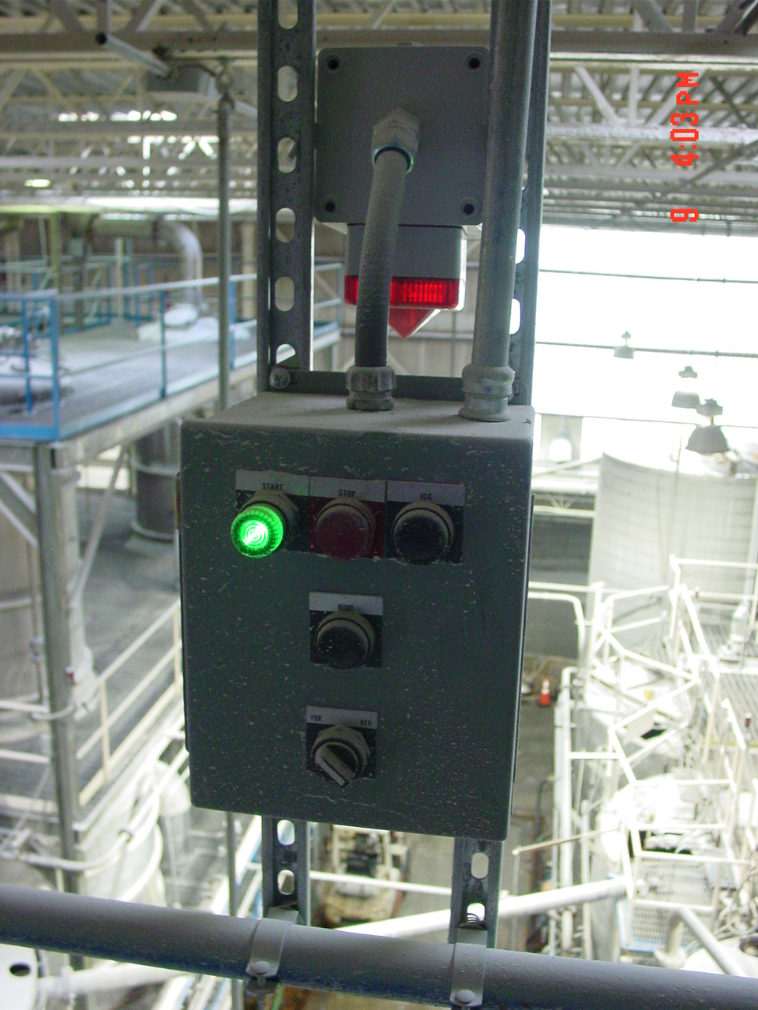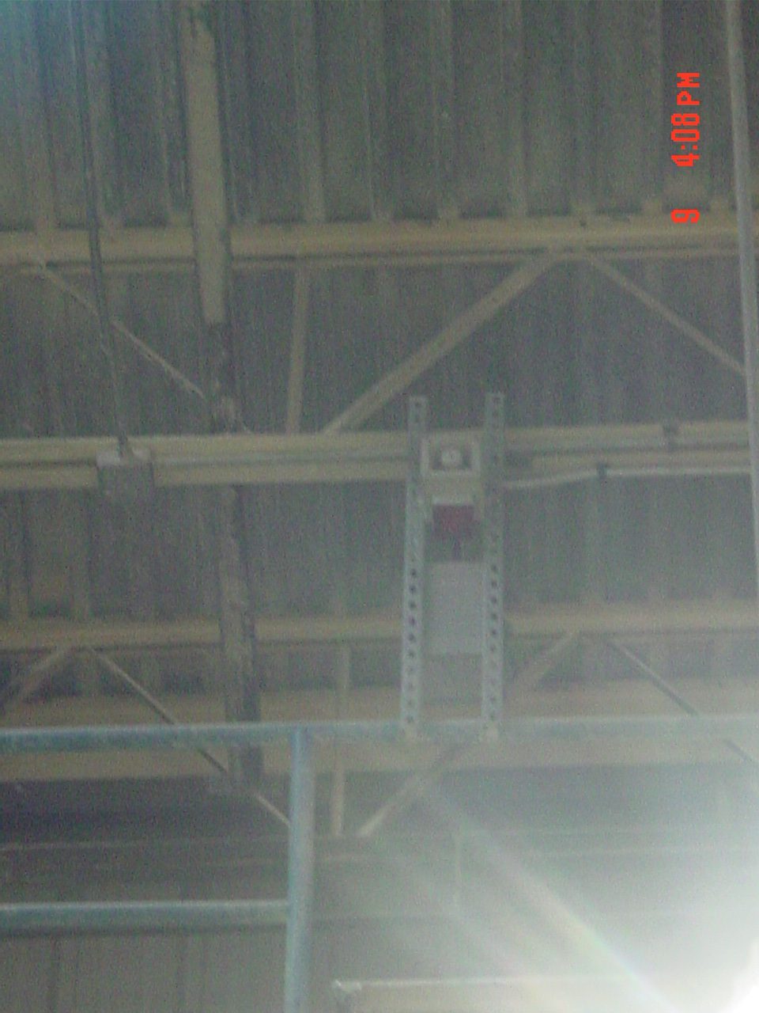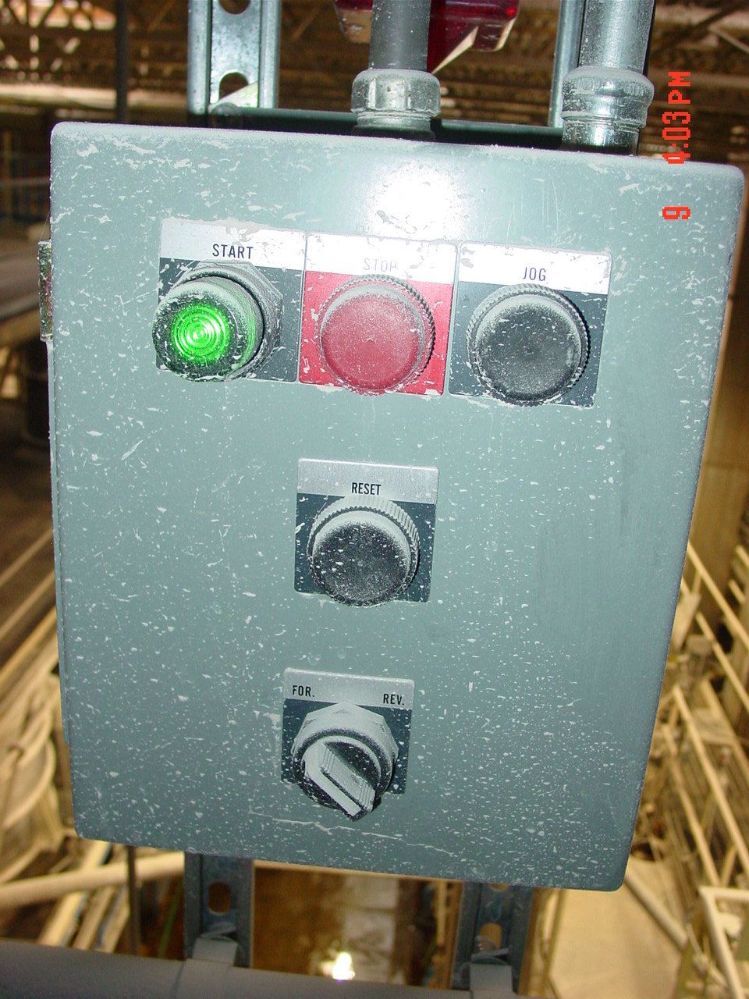
- Ensure that there is no fault in the system by reviewing the warning light and panel located adjacent to the long conveyor that feeds the liquid side of the plant (Digester Room). If fault has occurred system has to be cleared of obstructions and reset button pushed before proceeding to next step(s). Please turn in a work order if you remove the lids so we can re-seal the tops to minimize Mgo loss.

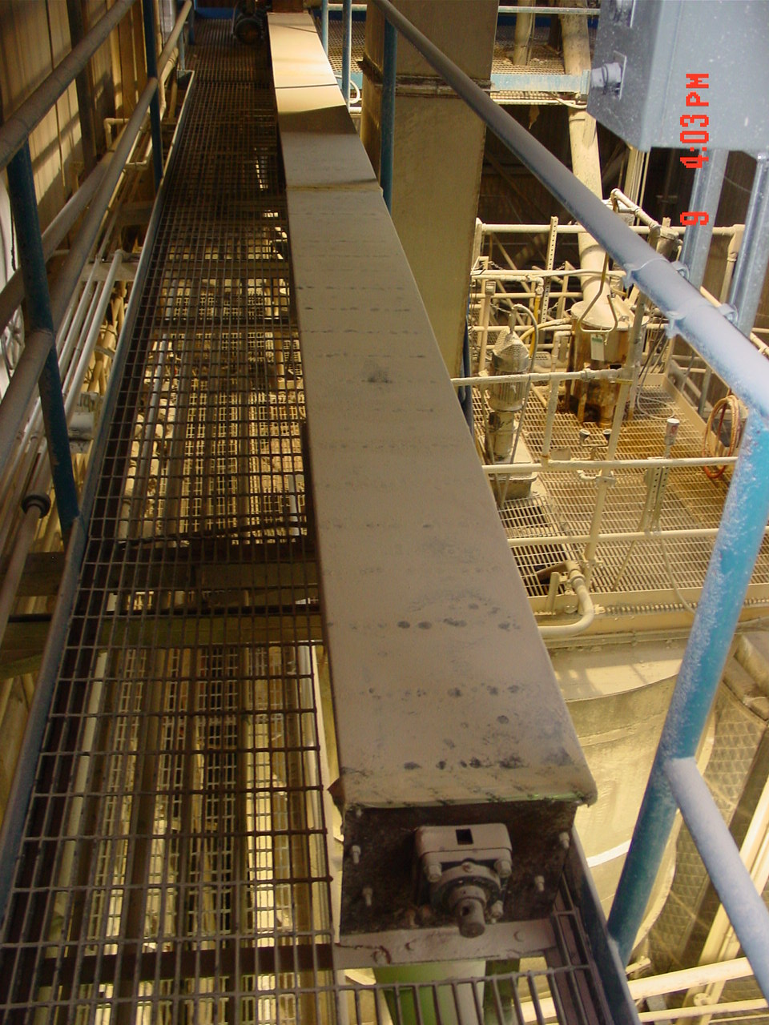
- Press the Reset button on the panel located adjacent to the long conveyor. Start the long conveyor screw feeding the liquid side of the plant. There is a second start/stop button on the wall if needed.
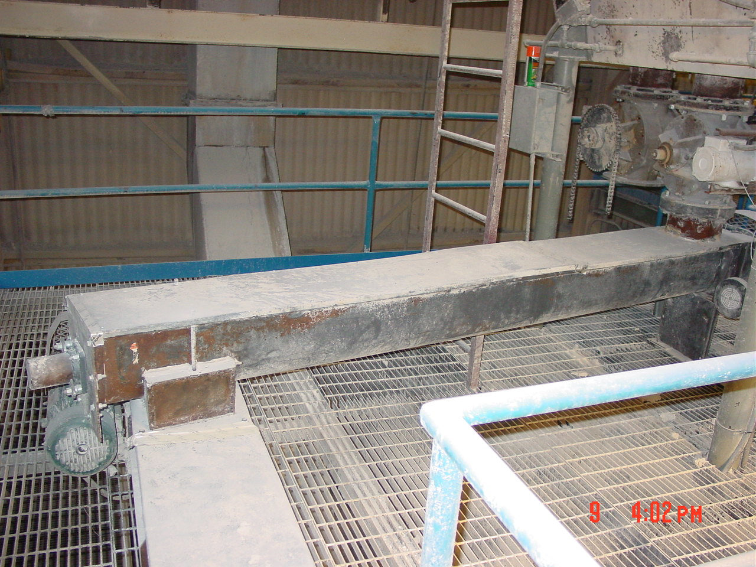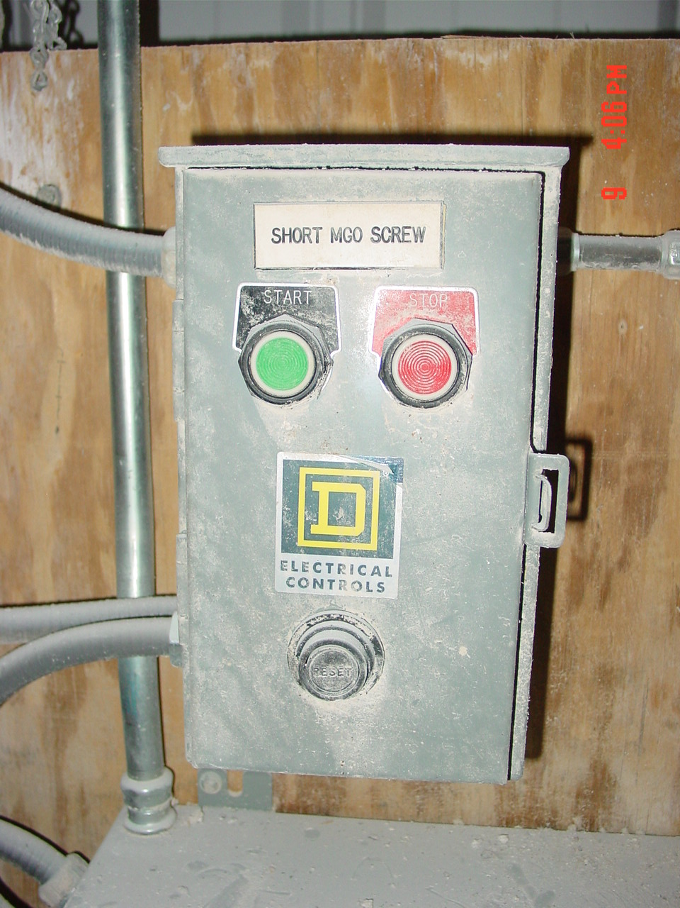
- After long conveyor is operating, start the short screw conveyor feeding the liquid side of the plant. This is accomplished by using the start stop button located directly below the short conveyor.

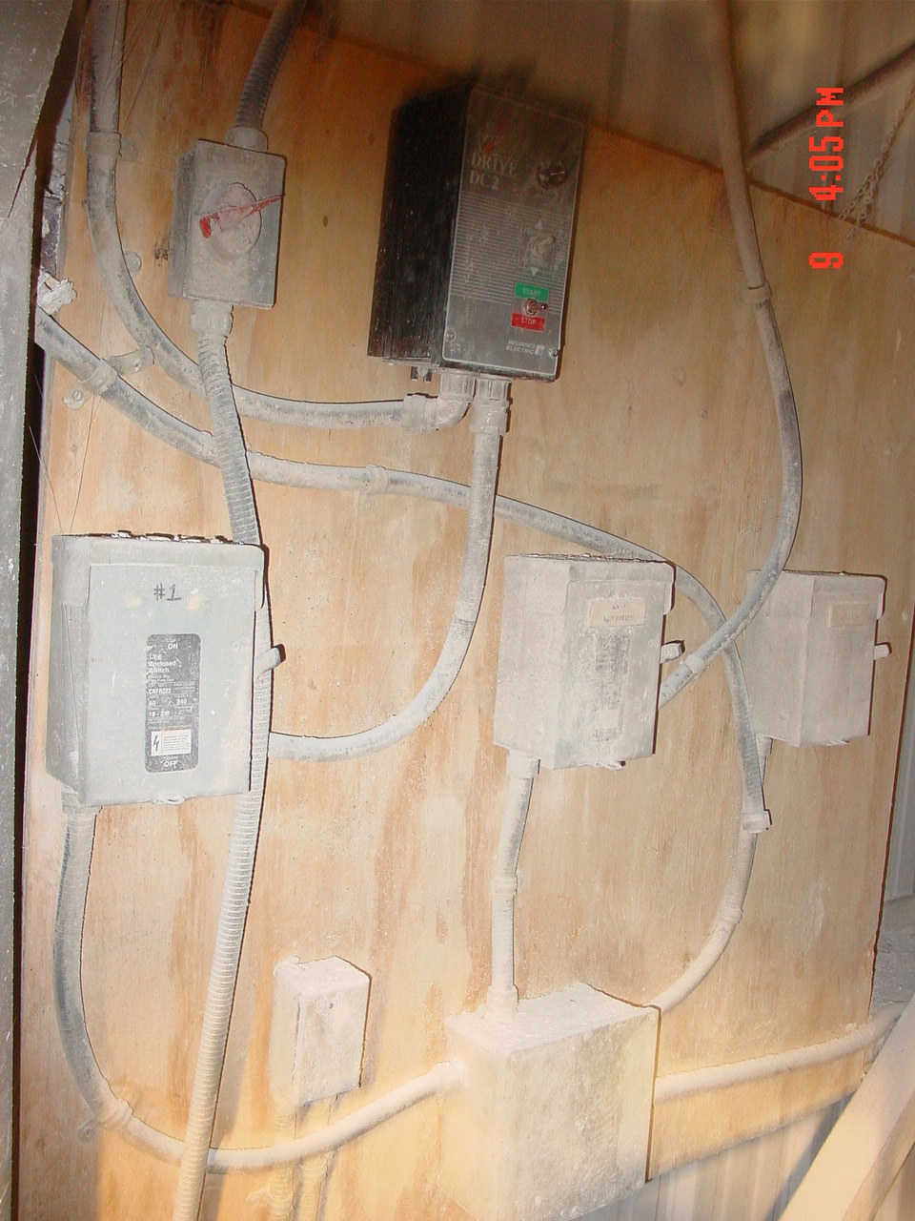
- After both screws are operational then start the rotary valve by using the start/stop buttons located one level below at the top of the digesters. (This start/stop is adjacent to the salt side digesters. The system should be functioning to feed Mgo to the plant. Please review day hopper procedure to move back further into the Mgo feed system.

- Reference Documents

N/A

- Change Information

New Procedure

